
Personal C.V.
Personal information:
Name: Mohamed abdel monem bedir abdo ebrahim .
Date of Birth: 9/7/1990
Nationality: Egyptian
Address: Elmagzan-Elsenbelawin-Eldaqahlya
social status: single
Military Status: finished
Telephone: 020506771383 Mobile: V-0201062047529-M-0201281500542 v-01007567805
eng_mohamed.civil@yahoo.com : E-mail
Education
B.Sc, Civil Engineering banha University faculty of engineering , Egypt –( 2014-2015 )
Grade:62.36%.
Project : theory of structures . (Excellent)

Skills
Qualification
Good Listener, high ability to learn, and to work with groups.
Adaptable, Attention to details, like to try solving problems
self motivated, good communication with others, Work under pressure.

Objective
Seeking a challenging career opportunity in a reputed company where I can harness my technical skills, work experience and creative towards making significant to the growth and development of company and thereby develop myself.

Career profile
I am agraduate in civil engineering and havening excellent professional experience in structure design and supervision and inspection of site works. I have capacity of monitor to the confidence to lead a team and personality to pass on skills experience to junior staff .evaluation and preparation of claims of variation order and extension of time , estimating the total cost of project and making a time program for it .

Plan and design transportation or hydraulic systems and structures, following construction and government standards, using design software and drawing tools.
Compute load and grade requirements, water flow rates, and material stress factors to determine design specifications.
Direct or participate in surveying to lay out installations and establish reference points, grades, and elevations to guide construction.
Estimate quantities and cost of materials, equipment, or labor to determine project feasibility.
Prepare or present public reports, such as bid proposals, deeds, environmental impact statements, and property and right-of-way descriptions.
Test soils and materials to determine the adequacy and strength of foundations, concrete, asphalt, or steel.
Using American code for loads UBC
DESIGN WOODEN BULDINGS ACCORDING TO ACI
AND STEEL STRUCTURE BULDING .

Computer Skills
Ansys very good
AutoCad Excellent Etabs Very good
Sap2000 Excellent Safe Very good
Ms-Excel Excellent PCAColumn good
Ms-Office
Very good revit structures
Csi-columns Very good Section Builder Very good
3dmax and cad 3d verygood
Very good revit structure

In addition to
Introduction to internet technology –HTML
Programming using Ms-Excel Excellent
working on photoshop (very good) ,sketch up (very good)

Language Skills
Mother tongue : Arabic
Foreign language : English and French speaking and reading is very good .

Training
At arab contractor company osman ahmed osman
Of inspection civil works which includes structural and finishing and ensure that the work is as a per the project specifications and issued for construction drawing ,final approved drawings from authorities .
Ensure that all works meets to stipulated quality standard .

WORD TO SAY
Finally I can say that I loved civil engineering cause of it is the base of civilization of any country and I wish that I will exert a great efforts for being distinguished mark in civil engineering world.

Curriculum Vitae

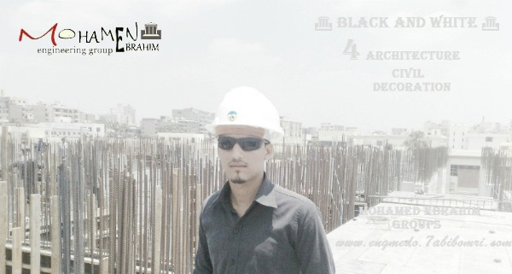

CERTIFICATE
